Jimmy Vang

Intro to Java

11/16/2016

**Testing Document**

**Lab 6_01**

File Name(s): “PersonDemo.java ”, “Person.java”

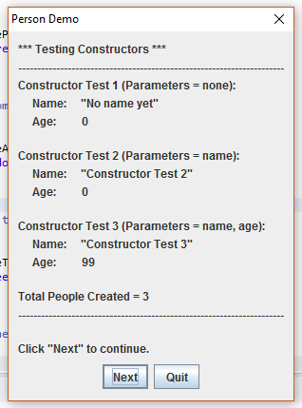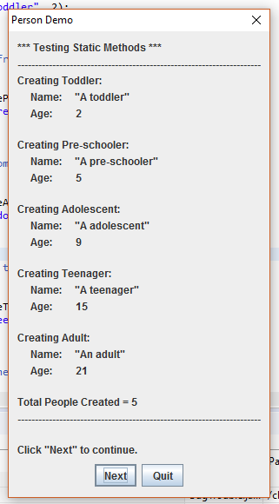 The purpose of this class file is to test the modified “Person.java” class file using “PersonDemo.java”. The demo tested the constructors and static methods of the Person class. Every thing seems to work as shown below.